**REPORT**

**Grapes Classifier**

by

**Nilesh Zagade**

**Hrishikesh Satarkar**

**Sanskrati Gupta**

Under the Guidance of

**Dr. Parnika Kekre. & Mrs. Sumitra Pundlik.**

**ABSTRACT**

This report presents a depth see-through the Grapes classifier. This project is carried out in Ubuntu 18.04 bionic . This classifier is capable of classifying the image of bunch of grapes into healthy and unhealthy depending on certain constraints. Those particular constraints are further mentioned in the report. Primary data collection technique is used for data collection. The collected data is further labeled using ‘Labelimg’. In this project, YOLOV3 algorithm has been used along with darknet feature extractor (DNN) in combination to train the data set while the technique used to train the data is Iterative K-fold validation with shuffling.

Table of Contents

|  |  |
| --- | --- |
| Contents | Page No. |
| Abstract | i |
| Table of Contents | ii |
| List of Figures | iii |

|  |  |  |  |
| --- | --- | --- | --- |
| Chapter 1: | Introduction | | 01-03 |
|  | 1.1 | Problem Statement | 02 |
|  | 1.2 | Objectives | 02 |
|  | 1.3 | Component description | 02 |
|  | 1.4 | Organization of report | 03 |
| Chapter 2: | System Design | | 04-06 |
|  | 2.1 | Activity Diagram | 05 |
|  | 2.2 | Use-case Diagram | 06 |
| Chapter 3: | System Implementation | | 07-13 |
|  | 3.1 | Technology | 08 |
|  | 3.2 | Results and Analysis | 10 |
| Chapter 4: | Applications | | 14-15 |
| Chapter 5: | Conclusion and Future Scope | | 16 -17 |
|  | References | | 18 |

**LIST OF FIGURES**

|  |  |  |
| --- | --- | --- |
| **Figure No.** | **Caption** | **Page No.** |
| 2.1 | Activity Diagram | 05 |
| 2.2 | Use-case Diagram | 06 |
|  |  |  |
|  |  |  |
|  |  |  |

**Chapter 1:**

**Introduction**

**1. Introduction:**

This is an Image processing project that successfully classifies grapes image into healthy and unhealthy category. This project required a lot of data conversion which was achieved using various scripts and assigning dummy variable.Coming over the training algorithms and the framework, images converted into 416 X 416 was used apart from that we had an option of 320 X320 and 608X608 which would apparently produce less mPA (mean average precision) and take more tie respectively.We have used iterative k-folds validation with shuffling technique for training our model which apparently took longer period to train but gave higher accuracy. To use this technique, the data needs to be divided into batches and further into subdivisions which are trained in an iterative manner. The data was converted into 64 batches and those batches were further subdivided into 32 subdivisions. We gave 4000 iterations to each and every batch of data which turned a sample of 100 images into massive 256000 images.

## 1.1 Problem Statement:

Classifying an image containing grapes into healthy and unhealthy.

**1.2 Objectives:**

1. Considerable accuracy of the trained weights.(Obtained 99.8)
2. Avoiding miss classification (i.e the model should pass no comments if Grapes are absent in the image.)
3. Successfully categorizing grapes image into specified classes.

## Features:

1. Darknet :

* A deeper architecture used by Yolo algorithm for feature extraction.
* Consists of 53 convolutional layers

1. YOLO-V3 :

* Yolo-“You Only Look Once” is an algorithm that uses convolutional neural networks for object detection. You only look once, or YOLO, is one of the faster object detection algorithms out there. Though it is not the most accurate object detection algorithm, but it is a very good choice when we need real-time detection, without loss of too much accuracy.
* This algorithm uses a combination of 106 layers of neural network for training the model. Out of these 106 layers, 53 are CNN neural layers while 53 layers belongs to darknet framework(feature extractor).

**\*Object confidence and class predictions in YOLO v3 are predicted through logistic regression.**

1. Training strategy :

* The strategy used in training the model is iterative k-fold validation with shuffling.
* K-fold is nothing but splitting the data into k partitions of equal size.For each partition i, the model is trained with remaining k-1 partitions and is evaluated on partition I.
* This process is iterated several times and shuffling data every time before splitting it into k partitions.
* The accuracy is calculated using Intersection over unions which is calculated by the division of area of overlap to the area of union.

## 1.4 Organization of Report:

In the chapter 1, we have introduced our problem statement, its objectives and features. Chapter 2 provides project system design. Chapter 3 consists of the technology and system implementation results and analysis. Chapter 4 comprises of system application. In the chapter 5, conclusion and future scope is provided.

**Chapter 2:**

**System Design**

**2. System Design :**

**2.1 Architecture Diagram**

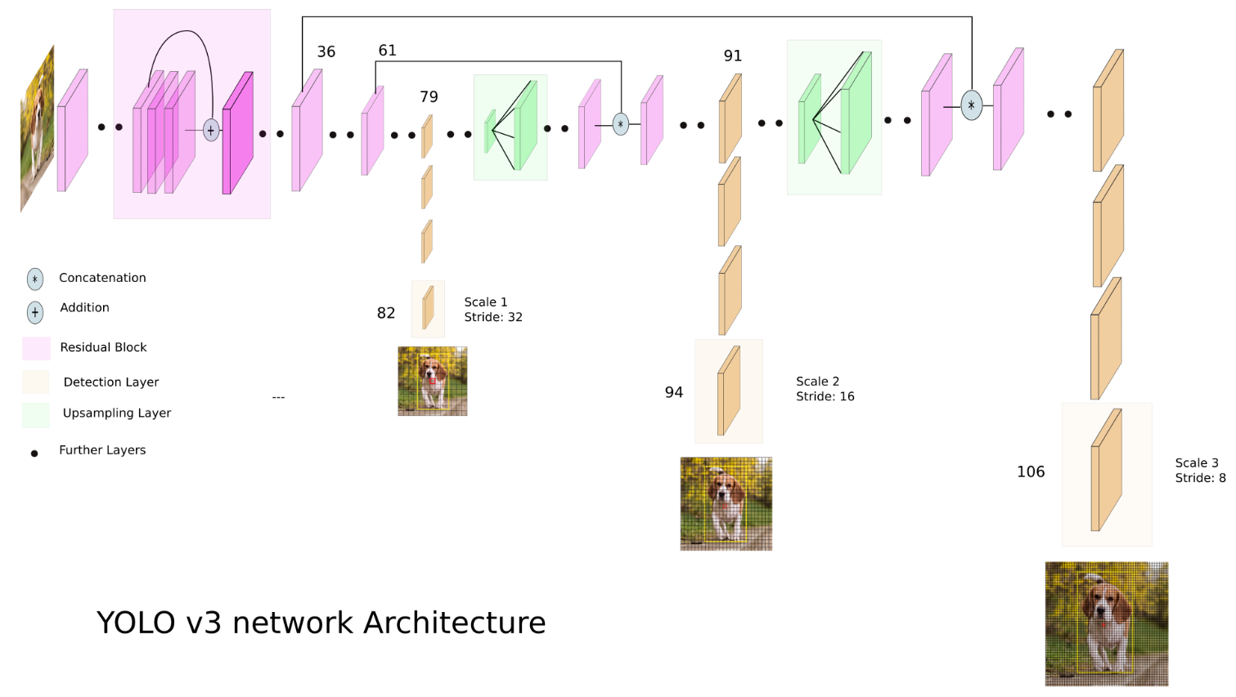

**Figure 2.1: Architecture Diagram**

**2.2 Use-case Diagram**

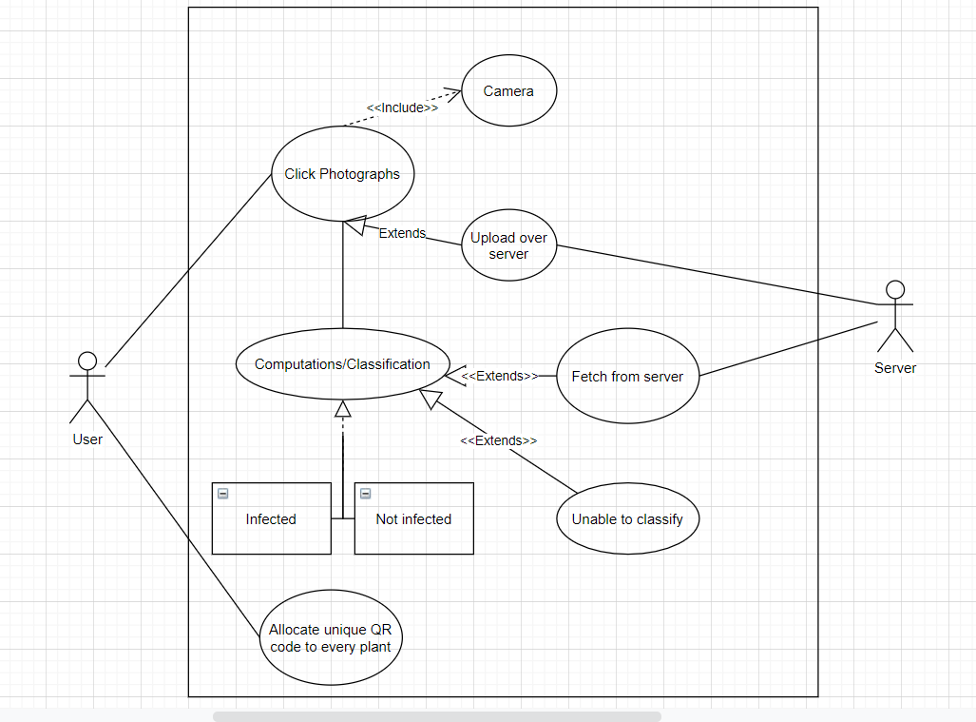

**Figure 2.2: Use-case Diagram**

In the use-case diagram, a primary actor and a secondary actor (server) is bought into the picture.

This diagram defines specifies that the user needs to allocate a unique QR code to each and every plant for its identification.

This is an image processing model which will require a camera for its dynamic usage. The user has choice whether to upload that photo over server/cloud.

The captured image will be processed for classifying its content into Healthy or unhealthy.

**Chapter 3:**

**System Implementation**

**3. System Implementation :**

**3.1 Technology**

**Platform :** Ubuntu 18.04

**Software and Frameworks used :** Darknet, Cuda, cudnn, Labelimg, YOLO V3,Custom Dataset.

Hardware : i5 8500 processor, nvidia geforce gtx 1060 graphics card.

**3.2 Results and Analysis**

The model was successfully able to classify 99.998%.

This was calculated using IoU Intersection over unions.

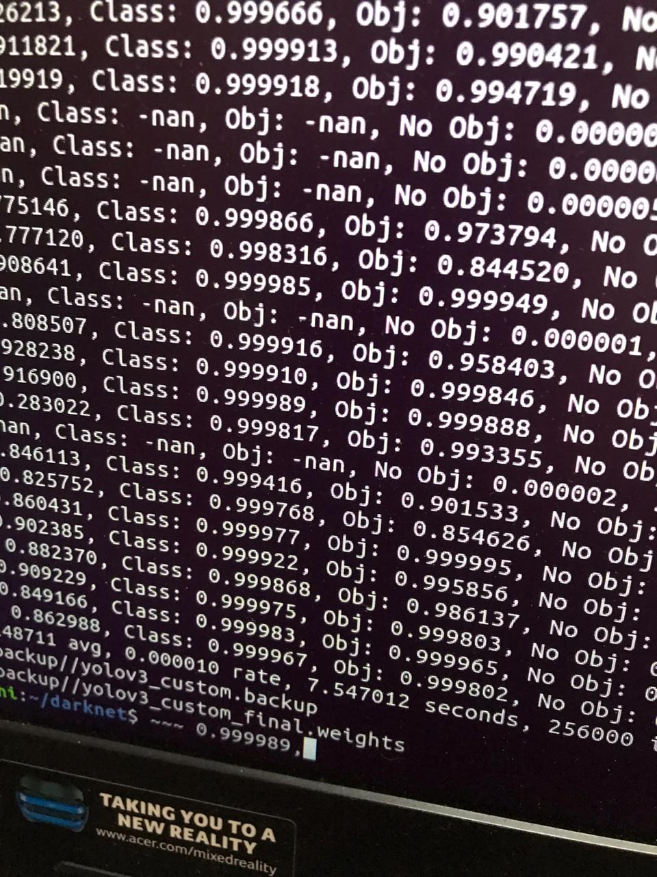

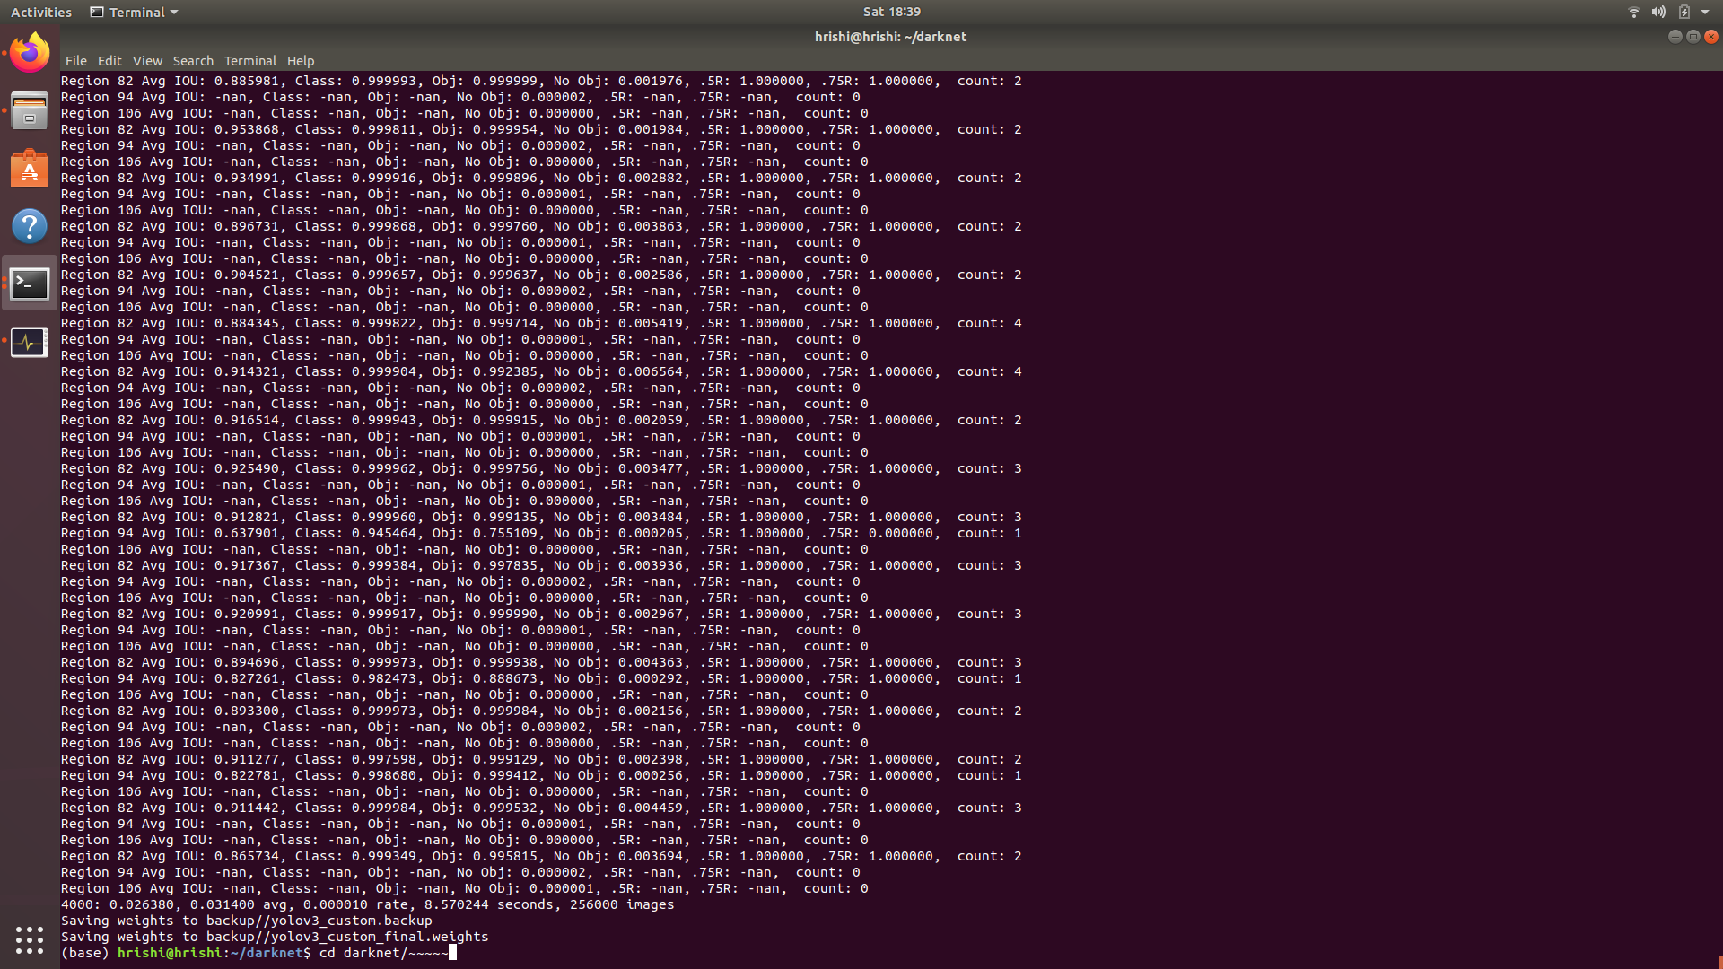

This screen shot was taken at the end of training.

In the above image we come across Region 82, 94 and 106 those are nothing but the results obtained at that particular level of neural network.

.5R and .75R is the region in the image. In initial stages of training, the values associated to those variables is adequately less as the model is not trained to identify the presence of target object but once the model gets trained, the values of those variables is either 1 or -nan means there is an object in that% of region or not respectively.

Count indicates the number of bounding boxes in those respective regions.

-nan is to indicate there in no object in that particular region while class tells the image within the process is belonging to some or the other class as per the prediction.

After every iteration it tells the count of the iteration, loss obtain4ed in that particular iteration , overall loss rate of learning, time taken by the iteration and the number of images the model has gone through till now.

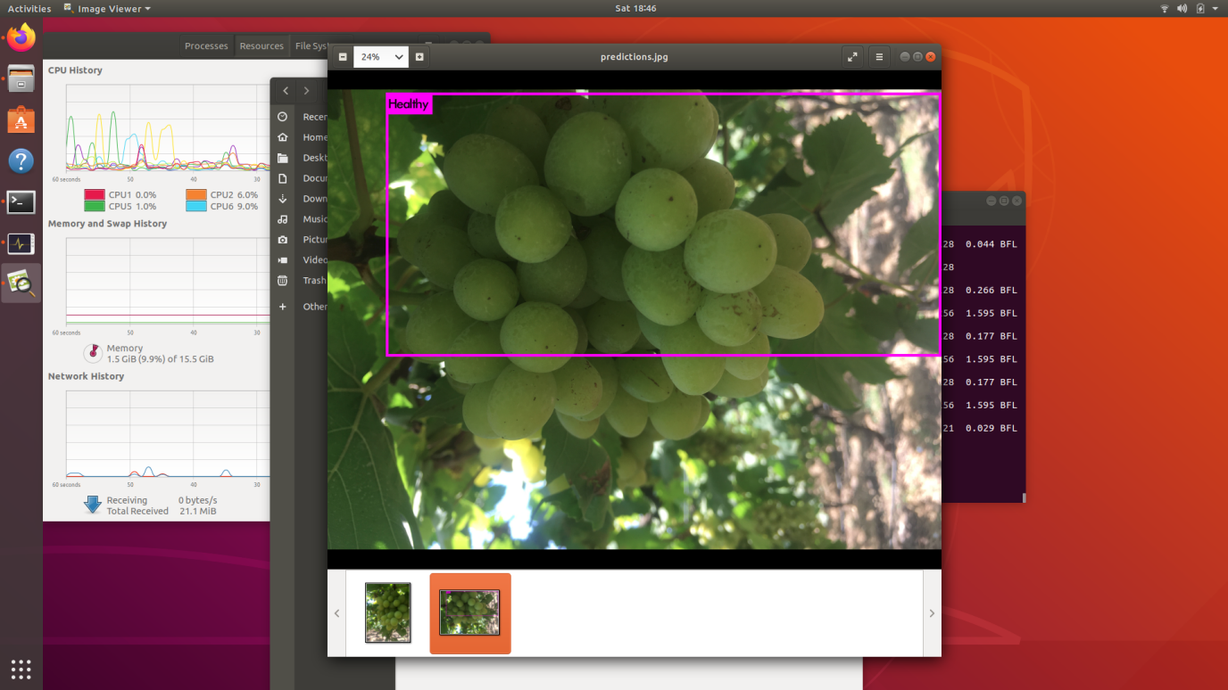

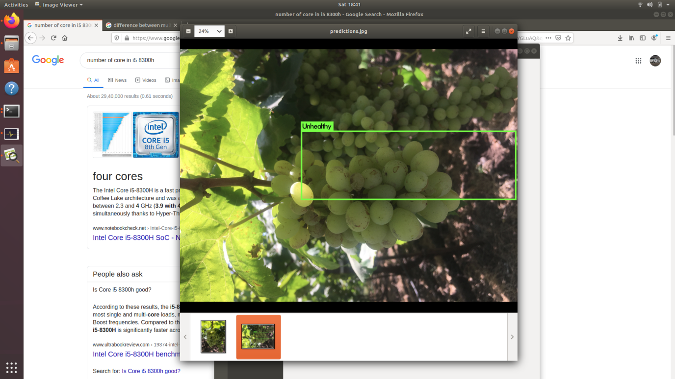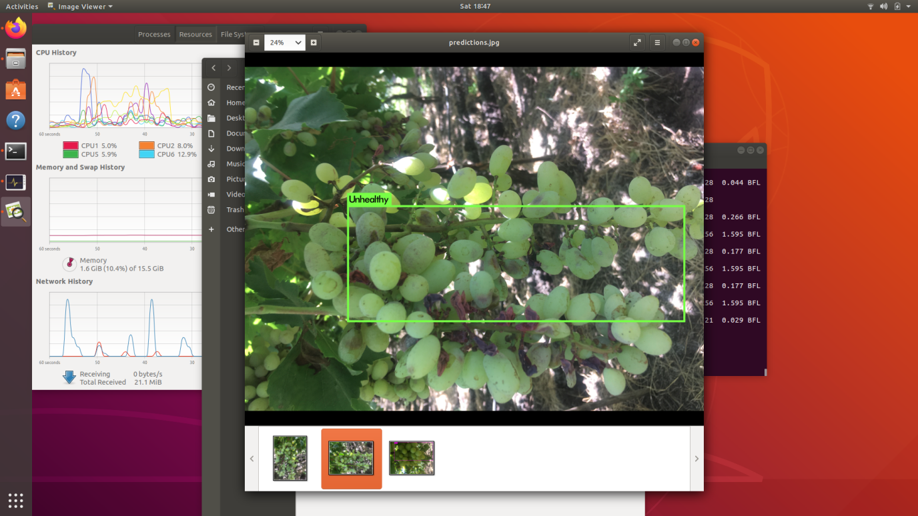

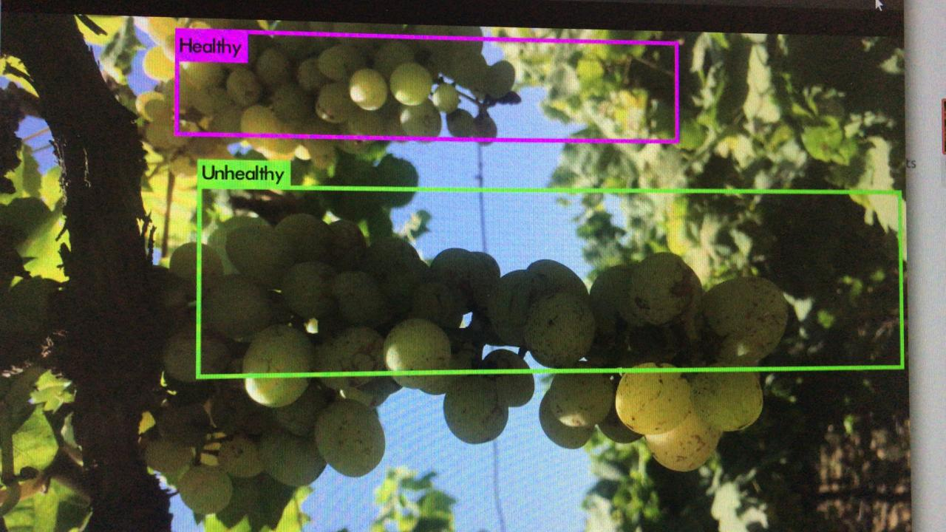

**Chapter 4:**

**Applications**

**4. Applications :**

1. It can be used for research purposes.
2. The model could be trained to detect the variation within the species.
3. If it is trained in a fashion then it could also be able to detect different types of diseases possessed to a particular plant.

**Chapter 5:**

**Conclusion and Future Scope**

**5. Conclusion and Future Scope** :

Conclusion :

Concluding our project, the submitted model is reliable for distinguishing an image containing a bunch of grapes into infected and Healthy.

Future Scope :

The algorithm could be integrated over a board attached to a rover that could autonomously traverse a vineyard and detect infected bunch of grapes and traverse photos of infected ones over the cloud.